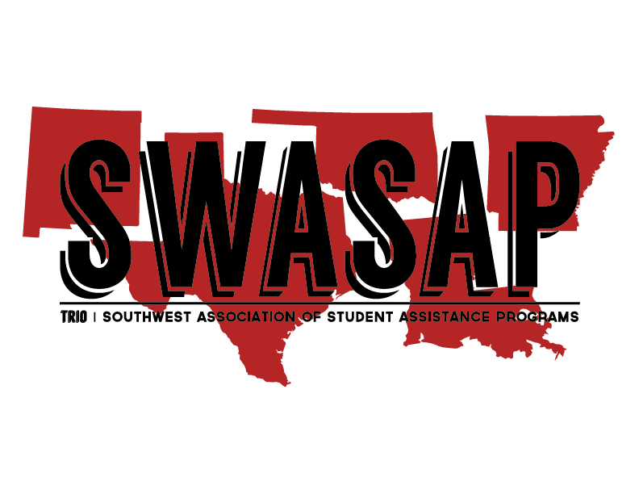
Candidate Information:

SWASAP 2018

OFFICER NOMINATION FORM

Position Seeking:
€ President-Elect € Treasurer
Name: Title:
TRIO Program: Institution:
E-Mail: Phone:
Address:
Professional Years w/ TRIO: Years in SWASAP:
TRIO Supervisor Approved Candidacy: € Yes (Letter of Support Attached) € Not Applicable
Institutional Supervisor Support: € Yes (Letter of Support Attached)
I have read all the requirements to the position I am running for, and I am able to perform all duties listed. To my knowledge all SWASAP and state association dues have been paid and my membership is active.
Nominee’s Signature: Date:
Nominator Information:
Name: Title:
E-Mail: Phone:
Address:

Completed nomination packet must include: € Nomination Form € Letter(s) of Support
€ Candidate’s Resume € Candidate’s Photo
Submit nomination(s) NO LATER THAN October 5, 2018 to:
Alfred Bacon, Nominations and Elections Chair
Phone: (832)689-6348 Fax: (713)315-6404 E-mail: SWASAP.Elections@gmail.com

