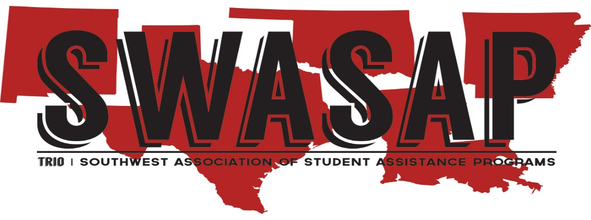

1. **TRIO Servant Award**

**This award is considered for an individual who is a current member of SWASAP, and who has also:**

* **Demonstrated continuing dedication to ensure educational equity**
* **Professionalism in implementing services or activities in his/her program and community**
* **Their contributions to the TRIO community go above and beyond what is expected for the success of his/her students and respective program**
* **Provides and participates in community service or organizations outside of TRIO**
* **Excelled in providing services to TRIO and/or to SWASAP at the local, state, or regional levels**
* **Been a member of SWASAP TRIO for at least 5 years**

**Nomination Procedures:**

* **Complete Nomination Form**
* **Provide a narrative of no more than 5 pages about the nominee on a separate sheet of paper addressing the following:**
  + **Describe and outline the nominee’s continuing dedication to ensure educational equity**
  + **How has this individual gone above and beyond what is expected by their position on campus and in the community that they reside in**
  + **Provide information about service the member provides to the community they reside in (if pertinent)**
  + **Provide other pertinent information supporting the nomination**
* **Provide a photo of the nominee**

**Application and all supporting documents must be received by Friday, October 21, 2022**

**Jeff Kahlden**

**Awards Committee Co-Chair**

**Dallas College**

**Office: 214-860-8589**

[**jkahlden@dallascollege.edu**](mailto:andrewg@unm.edu)

**OUTSTANDING SERVICE AWARD**

**Name of Nominee: __________________________________________________________**

**Mailing Address: ____________________________________________________________**

**Work Phone: _______________________ Cell Phone: __________________________**

**Email: _____________________________ Current Position: _______________________**

**Institution/Agency: __________________ Program(s): ___________________________**

**Number of years working in TRIO programs: _______________________________________**

**NOMINATION INFORMATION Provided by:**

**Name:______________________________ Program: _____________________________**

**Mailing Address: ___________________________________________________________**

**Work Phone_______________________________ Cell Phone:_______________**

**Email: __________________________ Current Position: _______________________**

**In what capacity do you know the nominee? ____________________________________**

**Are you a current SWASAP member? ______________ If so, which state? ___________**

**Are you planning on attending the 2022 SWASAP Annual Conference? Yes_____ No____**

**Is the nominee planning to attend the 2022 SWASAP Annual Conference? Yes_____No___**

**Application and all supporting documents must be received by October 22, 2022**

**Jeff Kahlden**

**Awards Committee Co-Chair**

**Dallas College**

**Office: 214-860-8589**

[**jkahlden@dallascollege.edu**](mailto:andrewg@unm.edu)