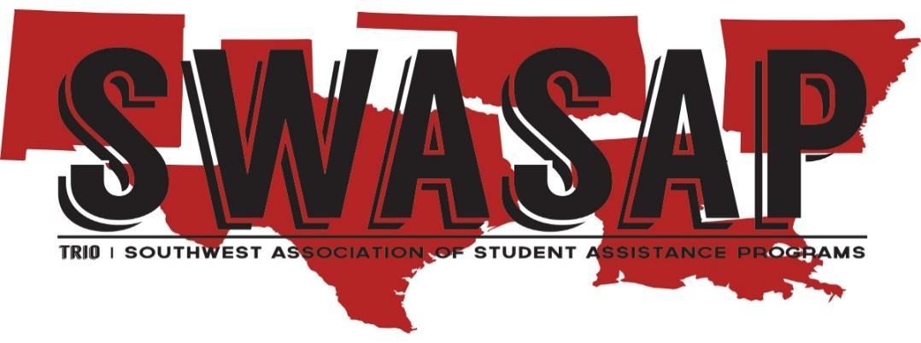

**2022 SWASAP Rising Star Award**

**This award is considered for an individual who is a current member of SWASAP, and who has also:**

* **Worked in TRIO for three years or less**
* **Excelled in providing services to TRIO and/or to SWASAP at the local, state, or regional levels**
* **Provided leadership and/or service to the TRIO community with their activities in the state, regional, or national levels**

**Nomination Procedures:**

* **Complete Nomination Form**
* **Provide a narrative about the nominee on a separate sheet of paper addressing the following:**
  + **Describe and outline the nominee’s length of service to TRIO programs**
  + **Provide other pertinent information supporting the nomination**
  + **Please provide any pertinent details about their services and work in TRIO from their supervisor**
* **Provide a photo of the nominee**
* **Provide a resume of the nominee**

**Application and all supporting documents must be received by Friday, October 21, 2022 by 5pm (CST).**

**Jeff Kahlden**

**Awards Committee**

**Office: 214-860-8589**

**jkahlden@dallascollege.edu**

**SWASAP TRIO RISING STAR AWARD**

**Name of Nominee: __________________________________________________________**

**Mailing Address: ____________________________________________________________**

**Work Phone: _______________________ Cell Phone: __________________________**

**Email: _____________________________ Current Position: _______________________**

**Institution/Agency: __________________ Program(s): ___________________________**

**Number of years working in TRIO programs: _______________________________________**

**NOMINATION INFORMATION**

**Name:______________________________ Program: _____________________________**

**Mailing Address: ___________________________________________________________**

**Work Phone_______________________________ Cell Phone:_______________**

**Email: __________________________ Current Position: _______________________**

**In what capacity do you know the nominee? ____________________________________**

**Are you a current SWASAP member? ______________ If so, which state? ___________**

**Are you planning on attending the 2022 SWASAP Annual Conference? Yes_____ No____**

**Is the nominee planning to attend the 2022 SWASAP Annual Conference? Yes_____No___**

**Application and all supporting documents must be received by October 21, 2022 by 5pm (CST).**

**Jeff Kahlden**

**2022 Awards Committee for SWASAP TRIO**

**Email:** [**jkahlden@dallascollege.edu**](mailto:jkahlden@dallascollege.edu)